**RUSSIAN SYMBOLISM (РУССКИЙ СИМВОЛИЗМ)**

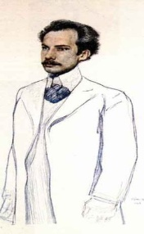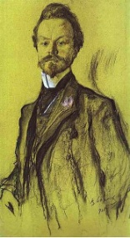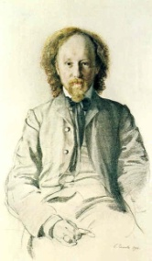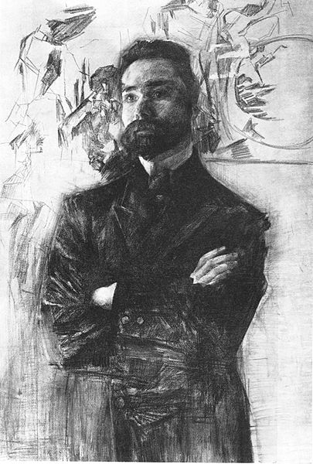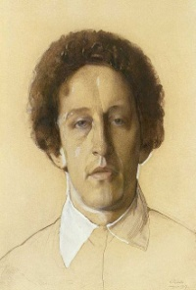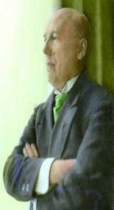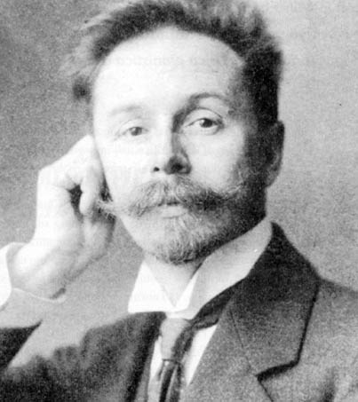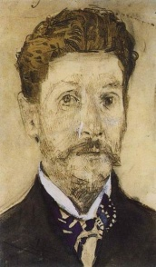

Major figures of Russian symbolism, from left to right: Andrei Bely, Konstantin Balmont, Vyacheslav Ivanov, Valery Briusov, Alexander Blok, Fyodor Sologub, Alexander Scriabin, Mikhail Vrubel

National branch of an international post-Romantic movement that originally appeared in France during the second half of the nineteenth century. The term was invented by Jean Moréas (1856-1910). The (French) founding fathers of this movement included Charles Baudelaire (1821-1867), Arthur Rimbaud (1854-1891), Paul Verlaine (1844-1896), and Stéphane Mallarmé (1842 -1898). The main concern of the Symbolists was focused not on the outward appearance of matters depicted, but rather on the inner plane of human metaphysical existence. Russian Symbolism emerged in the final decade of the nineteenth century with the first generation of writers (Valery BRIUSOV (1873-1924, poetry & prose), Konstantin BALMONT (1867-1942, poetry), Zinaida GIPPIUS (1869-1945, poetry, prose), Dmitry MEREZHKOVSKY(1865-1941, philosophical essays, poetry and historical novels), and continued into the first decades of the twentieth century with the ‘younger generation’ led by Aleksander BLOK (1880-1921, poetry), Andrei BELY (1980-1934, poetry, prose, philosophical essays), Vyacheslav IVANOV (1866-1949, poetry and philosophical essays), Mikhail KUZMIN (1872-1936, poetry and prose), Fyodor SOLOGUB (1863-1927, prose and poetry) and Maksimilian VOLOSHIN (1877-1932, poetry and essays).

**Origins**

Russian Symbolism was a major current of Russian modernism, largely parallel to the congenial European cultural models. Scholars commonly define “Symbolism” in Europe as a literary and artistic activity hailing from late 19th century French poetry and subsequently spreading to influence painting, theater, and literary history of the twentieth century to varying degrees. European Symbolism was rather late in coming to pre-modernist Russia. It was in 1894–95 that the poet Valery Briusov (1973-1924), who was an enthusiastic adherent of Symbolism, edited and published some anthologies of Russian and French Symbolist poems. Most of the poems in these anthologies were his own texts and free translations. The new revival of ‘experimental’ poetry in Russia stemming from this movement listed the philosopher and mystic poet Vladimir Soloviev (1853-1900) as its philosophical predecessor and spiritual authority. His metaphysical poetry professed a coherent religious doctrine that endeavoured to contemplate the world as a unique system of symbols relating to certain non-empirical realities. After his death (in the symbolic year of 1900 that was also the year of Nietzsche’s and Oscar Wilde’s death) Soloviev was succeeded by yet another principal theoretician of the Symbolist movement, Vyacheslav Ivanov (1866-1949), who was a well-versed expert in Greek and Roman cultural history and philosophy (like Soloviev) and was much interested in Plato and the Neoplatonic ideas. In this context we may also note the interesting cultural fashion in Russia that advocated a certain degree of imitation of the lifestyles and famous gestures of influential Western cultural icons. Many Russians in the late nineteenth century, and then in the SILVER AGE, fashionably copied the life-practices of cultural icons from the immediate past of Western Europe. The culture of this period in Russia was overloaded with life-creational post-Romantic behaviour.

Symbolist literary and cultural practice can be traced to the youthful rebellion of a number of French poets, who opposed the traditionalist tastes and regulations that had thereto dominated in mainstream poetry (especially the “Parnassian” type). Symbolism as a movement initially strived to emancipate art (and poetry in particular) from the burden of the outdated regulative norms by propagating the revolutionary agenda of inner experience and metaphysical existence. This post-Romantic approach resulted in subject matter replete with many bizarre myth structures and all kinds of obscure mysteries, metaphysical speculations, and playful fantasies introduced to buttress the perception of supernatural reality. Aestheticism is the quintessential factor responsible for the eventual embodiment of Russian Symbolism in all its specific fashions and configurations. The major thrust of Aestheticism was to redefine the relationship between art and life. As the work of Leon Chai has clearly shown, Aestheticism sought to transform multiple aspects of physical life into a work of art.

The timeline of the modernist Symbolist activity in Russia spans two decades between 1895 and 1915. This period embraces the early writings of the elder or first-generation Russian Symbolists (Merezhkovsky, Gippius, Balmont, and Briusov) at the one end, and those of the younger Symbolists Bely and Blok, at the other. The pre-modernists of Russian Symbolism, as well as the canonical modernists of the Russian avant-garde were interested in ‘creating life’ by the means of their art and aesthetic programs. Symbolist artists sought to express individual emotional experience through the subtle and suggestive use of symbolic, hyperbolized mythical and utopian language and artistic devices.

One may use the term “decadent” along with “Symbolist” to denote the entire fin-de-siècle cultural atmosphere, particularly intensive during the last decade of the nineteenth century. Decadence can be grasped as a transgressive phenomenon that aspires to move beyond all traditional boundaries. According to this view, decadence (and Symbolism) may be perceived as a transitional phase between pure Romanticism and Modernism of the Avant-Garde. The period from the 1890s to 1917 was characterized by an intellectual “overflow” in which mysticism, Aestheticism, dandyism, eroticism, Marxism, apocalypticism, Wagnerism, Nietzscheanism, and other trends effectively merged with each other. Most important was Friedrich Nietzsche, a poet among philosophers and a philosopher among poets, who was one of the major influences for Russian Symbolist life-creators. According to Alexander Nehamas, Nietzsche, as a life-creator, was shaping his life as a literary text par excellence, as an actual “novel” that bore many of the features of an “artefact” (consider *Ecce Homo*). In his extensive study of Russian mythopoetical symbolism, Aage Hansen-Löve asserts that the figure of Nietzsche established the paradigm for the symbolist myth of life. On the one hand, Nietzsche was seen as a typical representative of the Decadent movement, praised as the true founder of symbolist ‘life-creation’ (or even its mythic hero).

Apart from literature, Russian Symbolism left a notable impact on painting: the work of Mikhail Vrubel (1856-1910) testifies to that. The movement also extended to Russian music (Alexander Skriabin 1872-1915).

**Major Themes of Symbolist Works.**

Russian Symbolism arose out of a profound dissatisfaction with the positivist and realist outlook of the preceding decades. As a consequence, its major literary works were related to metaphysical panaesthetism, a belief that consciousness may be present in all matter. Many works of Russian Symbolists are in pursuit of an Ideal Beauty as counterpart to mundane life in the corporeal world (Alexander Blok, Fedor Sologub). Russian Symbolists’ thematic interests encompassed a wide range of issues: historical, mythical and life-creational. Most notable among the themes were those that romanticized Classical antiquity, the Middle Ages, and the Renaissance. These historical topics are prominent in the writings of Valery Briusov, Vyacheslav Ivanov, Dmitry Merezhkovsky, and Maximilian Voloshin. Another major theme of Russian Symbolism was suggestive eroticism as developed in the poetry and prose of Fedor Sologub, Mikhail KUZMIN, Valery Briusov, Konstantin Balmont, and some others. Political themes of the turbulent revolutionary period in Russian history also occupy a central place in the writings of AndreI Bely, Alexander Blok, Maximilian Voloshin, and Valery Briusov. Slavic folklore is another important inspirational topic for Russian Symbolism; it features prominently in the essays of Alexander Blok, Viacheslav Ivanov, and subsequently, in Alexei Remizov’s abundant prose. Finally, Russian Symbolism is strongly influenced by religious mysticism. This latter aspect is extensively present in the works of Alexander Blok, Viacheslav Ivanov, Maximilian Voloshin, Alexander Dobroliubov, and Andrei Bely. All of the above topics directly or indirectly correspond to Symbolism’s overall preoccupation with life-creational ideas that seek to aestheticize life and to make art an inspirational pathfinder leading people to hidden truths of existence.

**Major Works of Russian Symbolism in chronological order:**

Dmitry Merezhkovsky: *Leo Tolstoy and Fyodor Dostoevsky* (1901); *The death of the gods* (1901); *Peter and Alexis: The Romance of Peter the Great* (1906); *The Romance of Leonardo Da Vinci* (1908).

Valery Briusov: *Chefs d’oeuvre* (1895); *Me eum esse* (1897); Tertia Vigilia (1900); Urbi et Orbi, (1903); *Stephanos* (1905); *The Fiery Angel* (1908).

Konstantin Bal’mont: In the vastness of the Darkness (1896); Silence. Lyrical Poems (1898); The burning buildings. The lyrics of a modern soul (1900); Let us be like the Sun (1903); Only love. A magic seven-petal flower (1903)

Alexander Blok: Verses about the Beautiful Lady (1904); Inadvertent Joy (1907); Snow Mask (1907), Faina (1906-1908); Earth in Snow (1908); Night Hours (1911); Poems about Russia (1915); Motherland (1907-1916); Retribution (1910-1921); The Twelve (1918); The Scythians (1918).

Fedor Sologub: Bad Dreams (1895); The Petty Demon (1905); The Created Legend (1907-1914) ; Drops of Blood (1907-1913) ; Queen Ortruda (1907-1913) ; Smoke and Ash (1907-1913).

Andrey Bely: Second Symphony, the Dramatic (1902); The Northern, or First - Heroic Symphony (1904); Gold in the Azure (poetry) (1904); The Return –Third Symphony (1905); Goblet of Blizzards – Fourth Symphony (1908); Ash (1909); Urn (poetry) (1909); Symbolism (criticism/theory) (1910); The Silver Dove (novel) (1910); 1916 Petersburg (Revised edition published, 1922); Kotik Letaev (1922); Christ Has Risen (poem) (1918).

Viacheslav Ivanov: Guiding stars (1903); Transparency (1904); Eros (1907); Cor ardens (1911-1912); By the stars (1909); Furrows and boundaries (1916); The native and the universal (1917).

Mikhail Kuzmin: Toils (including Alexandrian Songs) (1908); Wings (1906); Tender Joseph (1909); Autumn lakes (1912); A dead woman at home (1913); Clay pigeons (1914); Trout is breaking the ice (1925).

Alexander Skriabin: Symphonic Poem in D minor (1896); Reverie, Op. 24 (1898); Symphony No. 1 in E major, Op. 26 (1900); Symphony No. 3 in C minor, Le Divin Poème (The Divine Poem), Op. 43 (1904); The Poem of Ecstasy, Op. 54. (1908); Prometheus: The Poem of Fire, Op. 60 (1910); Mysterium (unfinished) (1915).

Mikhail Vrubel’: Hamlet and Ophelia 1883; The Virgin and Child 1884; Angel with Censer and Candle 1887; Demon seated in the garden 1890; Fortune teller 1895; Flight of Faust and Mephisto 1896; Portrait of Savva Mamontov 1897; Bogatyr 1898; Pan. 1899; Six-winged Seraph (Azrael)1904.

**References and Further Reading**:

Nehamas, Alexander, *Nietzsche, Life as Literature*, Cambridge, Mass., Harvard University Press, 1985. [a good introduction for Nietzsche life-creation practices relevant to Russian Modernism]

Irina Paperno and Joan Delaney Grossman (eds.), *Creating Life: the Aesthetic Utopia of Russian Modernism*, Stanford, Calif., Stanford University Press, 1994. [a valuable collection of English-language articles on Russian Symbolism and Modernism]

Grossman, Joan Delaney, *Ivan Konevskoi: ‘wise child’ of Russian Symbolism*, Boston, Academic Studies Press, 2010. [an English introduction to the oeuvre of a less-known Russian Symbolist author of the first generation ]

Grossman, Joan Delaney, *Valery Bryusov and the Riddle of Russian Decadence*, Berkeley, University of California Press, 1985. [a best-known introductory monograph focused on the main Russian Symbolist writer]

Pyman, Avril, *A History of Russian Symbolism*, Cambridge, Cambridge University Press, 1994. [a concise descriptive history of the Russian Symbolism]

**Dennis Ioffe, Ghent University**

Source urls for pictures:

Andrey Belyi

Leon Bakst, Andrey Bely, 1905.

<http://www.artexpertswebsite.com/pages/artists/artists_a-k/bakst/Bakst_AndreiBely.jpg>

Konstantin Balmont

Valentin Serov: Portrait of the Poet Konstantin Balmont. 1905.

<http://commons.wikimedia.org/wiki/File:Konstantin_Balmont_by_Valentin_Serov_1905.jpg?uselang=ru>

Vyacheslav Ivanov

Konstantin Somov, Portrait of Vyacheslav Ivanov, 1906.

<http://commons.wikimedia.org/wiki/File:Viacheslav_ivanov.jpg?uselang=ru>

Valery Briusov

Mikhail Vrubel. Portrait of Valery Bryusov. 1906.

<http://commons.wikimedia.org/wiki/File:Vrubel_Bryusov.jpg?uselang=ru>

Alexander Blok

Konstantin Somov, Alexander Blok, 1907.

<http://img-fotki.yandex.ru/get/3109/innalove.17/0_ac9c_d0cdae39_XL.jpg>

Fedor Sologub

Portrait of Fyodor Sologub by Konstantin Somov, 1910.

<http://en.wikipedia.org/wiki/File:Fyodor_Sologub.jpg>

Alexander Skriabin

<http://commons.wikimedia.org/wiki/File:Skrjabin_Alexander.jpg?uselang=ru>

Mikhail Vrubel’.

Mikhail Vrubel. Self-Portrait. 1904.

<http://commons.wikimedia.org/wiki/File:Wrubel-selfportrait.jpg?uselang=ru>